## RDS Team Dynamics *Bi-Weekly Update*

**Assignment Goals / Deliverables:** Continuing the theme set with our first Team Dynamics assignment, we want you to get together with your team for a social activity either in-person or virtually (whichever you feel comfortable with). You can share a meal together, play a game, or something along those lines. This gathering should help you unwind a little, and allow you to reflect upon how your team has been performing over the last two weeks. As deliverables, we ask that you complete the following two tasks and upload them to the Canvas assignment:

Sam and Lio were absent for valid reasons the day this was taken

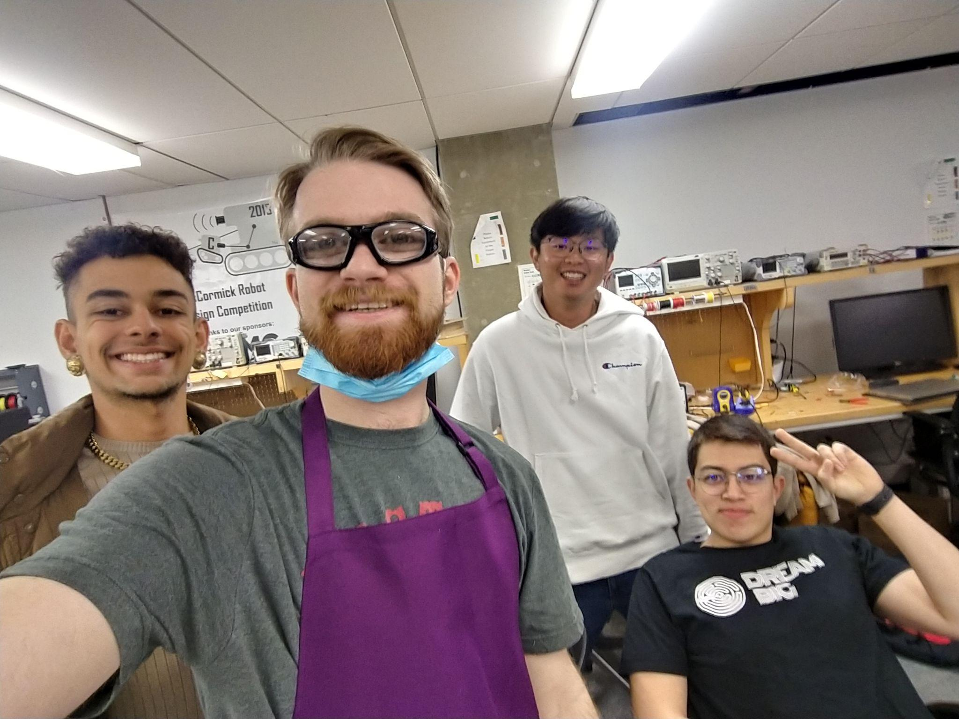

***Please be open and honest with yourselves and your group. There will be no penalties for the answers you provide in these bi-weekly updates, rather they should help you find areas for potential growth and help you recognize individual and team development.***

1. Have there been any conflicts or issues that have arisen within your team over the last two weeks? If so, what were they, and how were they resolved?

| There haven’t been any team conflicts or issues |
| --- |

1. Are there any conflicts or issues within your team that are still outstanding that you would like to discuss during your next weekly meeting?

| No |
| --- |

1. Are there any areas where you feel your team is excelling?

| We believe that thus far we have been great at setting and hitting our weekly goals and communicating those in an orderly fashion amongst each other (since we are now divided into 4 small subteams) and with the professors. We believe that setting up weekly update presentations where everyone contributes and communicates their achievements for the week has been particularly efficient! |
| --- |

1. Are there any areas where you feel your team needs improvement?

| Not particularly, as we go forward it will be important to continue communicating consistently as we move on to integrating all of our work into a single functioning device. |
| --- |